**HOMEWORK 5**

**Question No.1:**

**Complete the “Performance of languages on the RPi” tests explain in Chapter 5 for C/C++, Python, and**

**Java. Copy the results of the test for your answer.**

**Ans:**

**Question No.2:**

**Explain the differences in compiled, just in time compiled, and interpreted software languages and give examples of each one.**

**Ans:**

|  |  |  |
| --- | --- | --- |
| **Compiled Languages** | **Interpreted Languages** | **Jit compiled languages** |
| The compiled languages input is the whole program written in human readable language. | The interpreted languages take input in the form of instructions or single line of code. | The Jit compiled languages take byte code as its input and convert into native machine code. |
| The compiled languages execution speed is faster and produce intermediate object code as output. | The interpreted languages execution speed is slow and does not produce any object code as output. | Jit compiled language has faster speed and produce native machine code to increase the performance of java programs. |
| The error occurs first before compiling or during compiling and program execute when all errors removed. | The errors in interpreted languages occurs at run-time. | The errors in this language are occurring as user is making program logic and removing errors along with program development instead of removing at once which increase CPU load |
| This language delivers better performance. | This language delivers relatively slow performance. | This language is next-generation language and much faster than other languages with enhanced performance. |
| Example of compiled languages are: C, C++, C#, COBOL etc. | Example of interpreted languages are: Perl, python basic, JavaScript etc. | Example of Jit compiled languages are: JVM (Java virtual machine), Android, C# etc. |

**Question No.3:**

**Complete the “A First Circuit for Physical Computing” section in Chapter 5. Draw the wiring diagram of your completed circuit, give the commands used to control your LED, and insert two pictures (LED powered on and LED powered off by software control) into your answer.**

**Ans:**

**Wiring Diagram:**

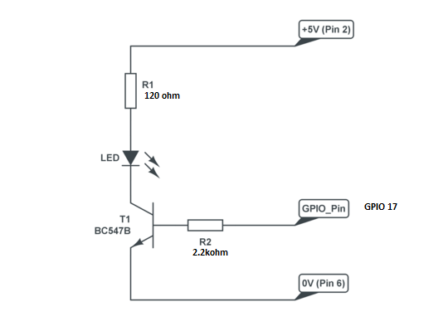

**Commands use to control LED:**

First assign the GPIO pin for LED output. The Commands used to control the LED are basically delay command which in python are ‘’time.sleep(1)’’. So, by using this command we add delay so that the led remain in ON state for mentioned time and also OFF for the same time.

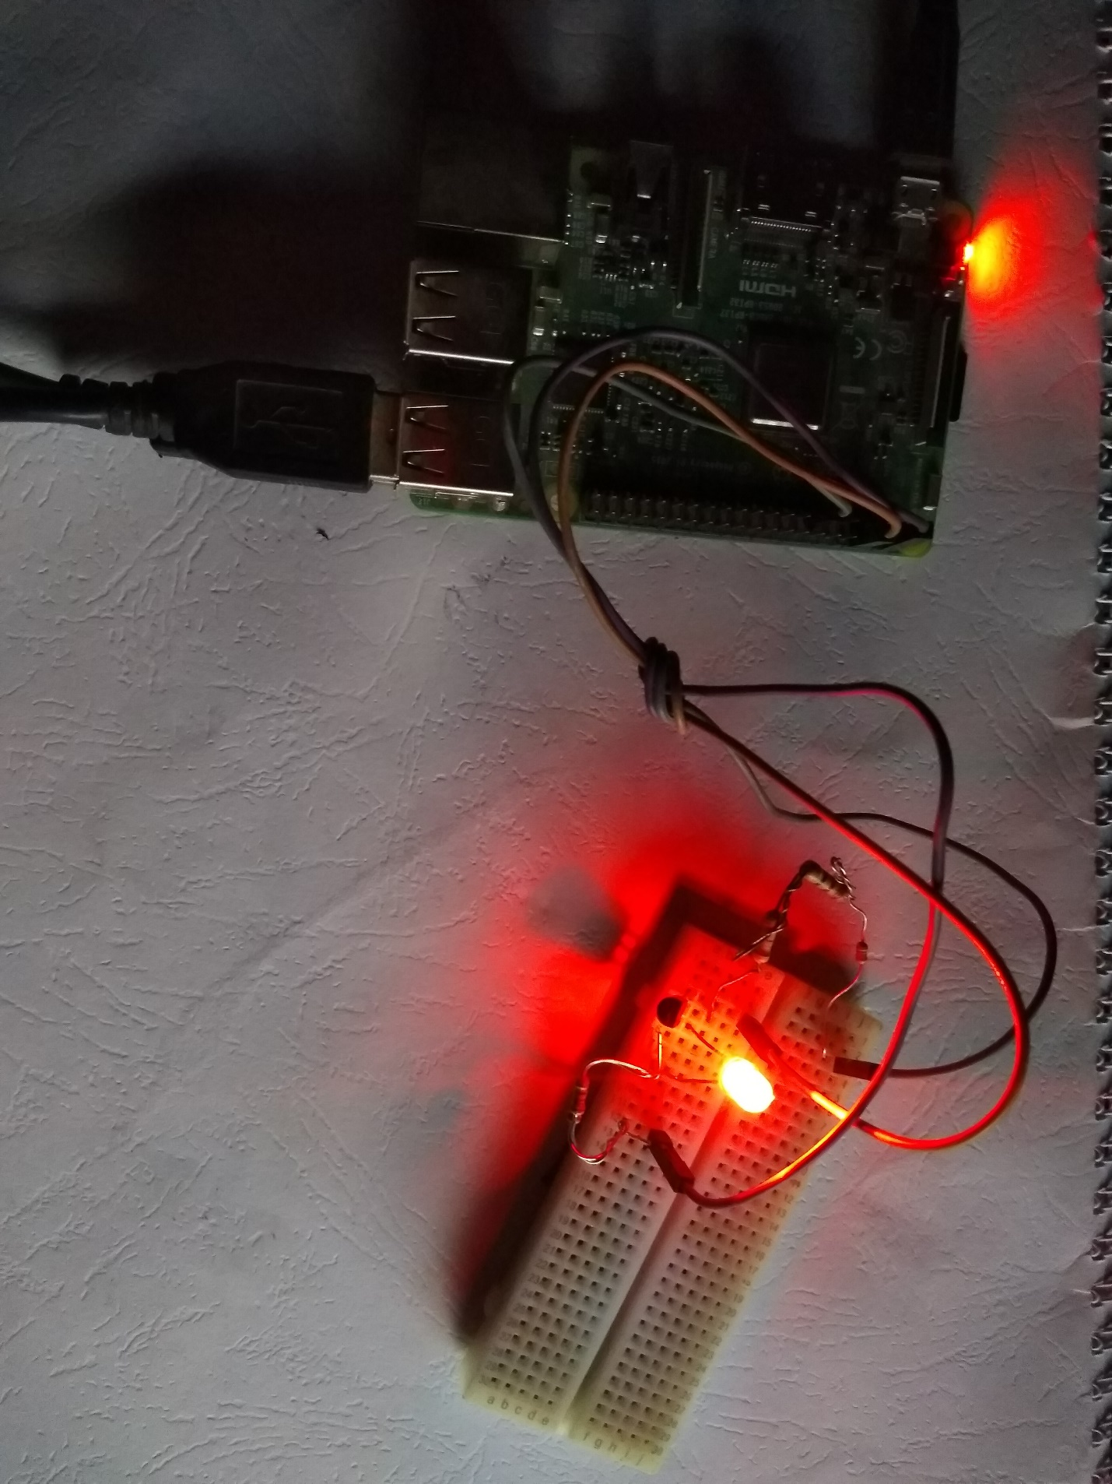

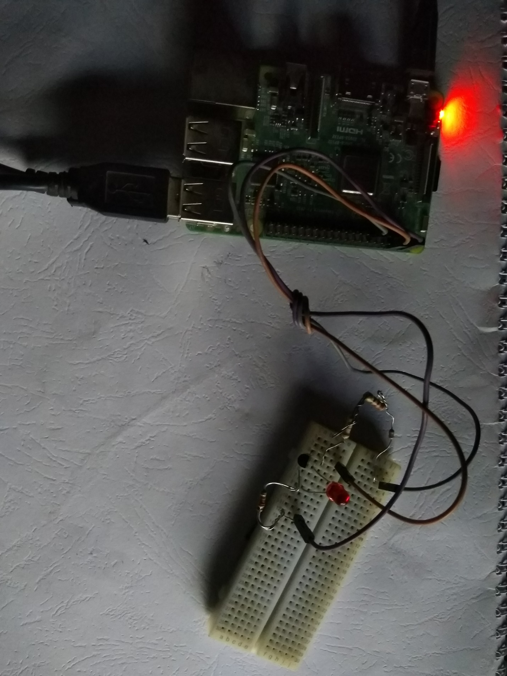

**Question No.4:**

**Give the program source code in Python, C, and C++ to blink the LED circuit in question 4 on/off in 0.5 second intervals.**

**Ans:**

**Python source Code:**

import RPi.GPIO as GPIO

import time

# physical pin addressing

GPIO.setmode(GPIO.BOARD)

# Set header pin no 11 as output for sending pulse to led

GPIO.setup(11, GPIO.OUT)

var=1

while var==1 :

  print ("LED ON")

  GPIO.output(11, False)

  time.sleep(0.5)

  print ("LED OFF")

  GPIO.output(11, True)

  time.sleep(0.5)

**Question No.5:**

**Describe three advantages and three disadvantages for each of the following programming languages when they’re used on the RPi: Python, C, and C++.**

**Ans:**

**Python:**

|  |  |
| --- | --- |
| **Advantages** | **Disadvantages** |
| Python program is short in length as compared to other languages program. | Python program performance is poor for slowing complex algorithms and numerical tasks. |
| Python program is perfect for automating Linux administration. | Python has less programming support in GUI, data structures, sockets and threads etc. |
| Python program is easy to modify and it can easily adopt changes. | Python programming lack of having development tools. |

**C:**

|  |  |
| --- | --- |
| **Advantages** | **Disadvantages** |
| C program can be written on the RPi or any other compiler because runtime environment cannot be needed like java. | C code run in one processor machine not able to run on another processor machine. |
| C programming used for high-performance user interface application development on the RPi using external libraries. | C do not support graphical user interface and network sockets etc. So external libraries are needed to use these features. |
| C languages are ISO standard and root software of controller are written in C, so you can further write new drivers in C. | C scripting is not suitable. |

**C++:**

|  |  |
| --- | --- |
| **Advantages** | **Disadvantages** |
| C++ programming provide high computational power capability especially when code is optimized. | C++ code prone to memory leaks by the use of pointers and low-level control variables. |
| C++ has full support for object-oriented programming, technical programming etc. | Like C, C++ also don’t support GUI and network sockets etc. So, libraries from third party developers are needed. |
| C++ and C languages are not language of single company. These are using everywhere because these languages are ISO standard. | C++ try to span from low-level language to high level programming tasks but it is very difficult to write very scalable enterprise. |